* 1. Which type of website you will be constructing (professional/portfolio or educational)? One short paragraph as to why you selected the specific project. 150-word maximum.
     1. Educational
        1. I have chosen to do the educational site due my personal interest in educational websites and free online learning websites. There are many sites that offer educational resources or information that are really well-done and I would like to be able to learn web development skills from that perspective. With this class, I’m sure I won’t get to the level of a site like Khan Academy or Shmoop or anything like that, but I’m still interested in having that mindset when working through these assignments. I would also like to use some of my knowledge and passion for superhero comic books. It’s something that I know enough about to not spend all my time researching, but I can still do some research in making content for the reference page. So, for this project, I will focus this website on educating viewers on the history of superhero comic books.
  2. Home Page Content. - All written content per the guidelines listed above.
     1. Hello! Welcome to this educational website covering the history of Superhero Comic Books in America.
     2. This site will introduce viewers to the world of superhero comic books from the golden age to the modern age. These pages will allow viewers to get an overview of each comic era, some key writers and artists in the field, and some major and minor superheroes that got their start in that era. The goal of this site is to give an introductory look of superhero comics to those new to the genre and to spike viewer interest in further exploration. Viewers of this website can expect to learn the following objectives:
        1. Learn the four main comic book eras: The Golden Age, The Silver Age, The Bronze Age, and the Modern Age
        2. The characteristics of each comic book era
        3. 2 major writers and 2 major artists of each era
        4. Superhero comic book characters from each era
  3. About/Educator Credentials Page Content. All written content per the guidelines listed above. Include your Photo (professional photo preferred!).
     1. My name is Jessie McCloy. I am a graduate student at the University of Missouri. I hope to gain my MLIS degree by the end of 2024. I received my bachelor’s degree in English from the University of Nebraska. I have loved libraries, archives, and museums my entire life. I currently work at Southeast Community College library. I’ve worked there full-time for a little over a year. I have past experience working in archives and museums such as the International Quilt Museum, the National Roller-Skating Museum, and UNL Special Collections. In my spare time, I like to build LEGOs, quilt, and read. I like to broaden my horizons by reading a lot of different types of books, including non-fiction. I’m passionate about traveling, but due to time and financial constraints, books tend to be the easiest way for me to visit other places.
  4. Projects/Experience OR Let's Learn Page Content. All written content per the guidelines listed above. (note this means you know what artifacts you will use and you can include the images.). *This can span 2 pages.*
     1. Golden Age
        1. 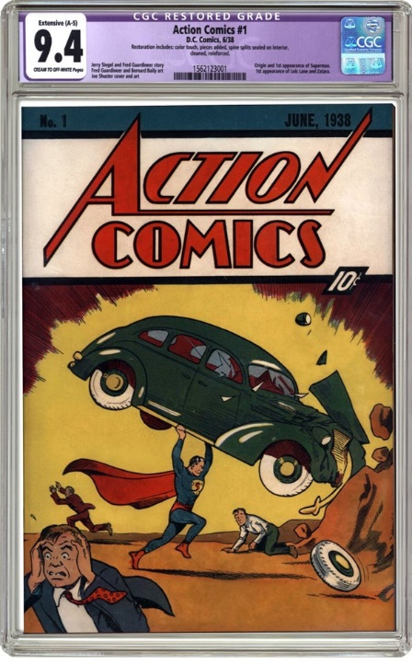Introduction
           1. The Golden Age takes place from 1938 to 1956. Many different genres of comic books became extremely popular during this era, including romance, crime, western, horror, and superheroes. Two of the most popular publishers of superhero comics were created in this era. National Comics (Later DC) and Timely Comics (Later Marvel) were both producing comic book characters that remain popular and well-read to this day. The most popular heroes to come out during this time are Superman, Batman, Wonder Woman, and Captain America. Important writers include Bob Kane, Bill Finger, Jerry Siegel, Joe Shuster, Jack Kirby, and Joe Simon. Although women in comics were not as common due to overt sexism in the industry, some women did make an impact on the comic book industry such as Toni Blum, Lily Renee, and Tarpe Mills.

Action Comics #1, 1938

X-Men #1, 1963

* + 1. Silver Age
       1. 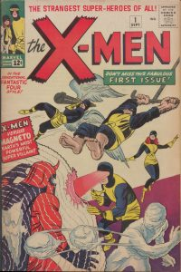Introduction
          1. 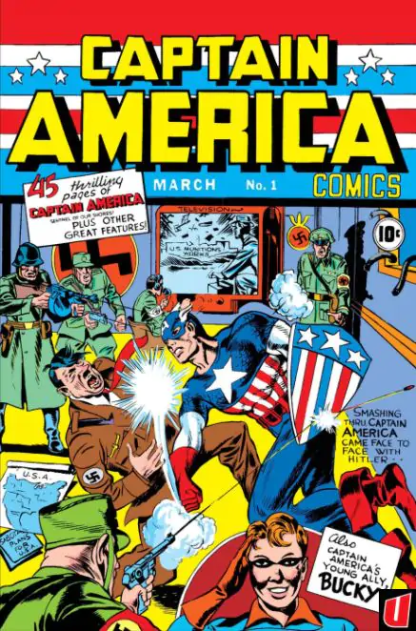The Silver Age takes place from 1956-1970. This era is characterized by declining comic books sales after WWII. It is also the era in which the Comic Code Authority came into effect. Due to the works of psychiatrist Fredric Wertham, comic books were targeted as corrupting the youth of America as talked about in Wertham’s book, Seduction of the Innocent. This regulation led to the death of many publishers, especially those focused on crime and horror comics. The superhero genre faired better. Writers such as Stan Lee, who grew up in the Golden Age, were now 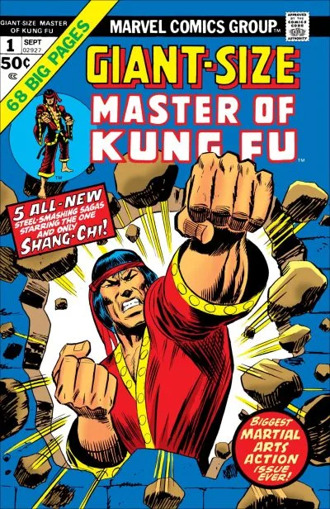creating superhero legends such as the Fantastic Four and Spider-Man.

Captain America #1, 1941

Black Lightning #1, 1977

* + 1. 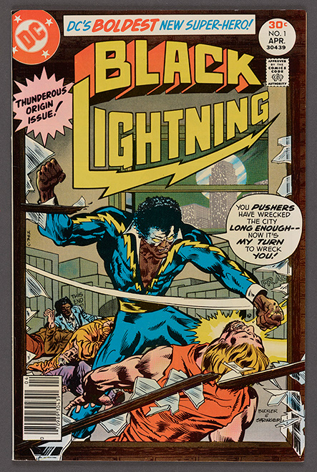Bronze Age
       1. Introduction
          1. The Bronze Age took place between 1970-1985. Artists and writers at this time could take more liberties with comic books as the Comics Code Authority Standards became more relaxed before disbanding altogether. In this new era, comics tended to be darker and more “realistic.” Comics at this time also dealt with social issues as can be seen in Green Lantern/Green Arrow series where they confront racism, drug addiction, and pollution. It was perhaps due to this new social awareness that heroes of color started to appear such as Luke Cage, John Stewart, and Shang-Chi. Popular artists

Giant-Size Master of Kung Fu #1, 1974

* + 1. Modern Age
       1. Introduction
          1. The Modern Age is classified as anything from 1996 to the present. This age is marked not only with comic books, but the adaptations in television and movies from Batman and Robin (1997) to Arrow (2012-2020). These adaptations have been viewed with mixed results, but have made the superhero comic book genre very popular in the mainstream. The Modern Era has also been a landmark for Marvel Comics and DC. For DC, Action Comics and Detective Comics have passed the 1,000 issues mark in 2018 and 2019, respectively. Marvel Comics, once on the verge of bankruptcy, has expanded into the MCU once acquired by the Disney Corporation. Popular writers and artists at this time include Todd McFarlane, Tom King, G. Willow Wilson, and many, many, more.
  1. Reflection/Teaching Philosophy OR References & Resources Page Content. Please follow the guidelines for each project type listed above.

Kowalski, Jesse. (2020). Comics: Comic books. Illustration History. <https://www.illustrationhistory.org/genres/comics-comic-books>

More Than a Century of Comic Books. (2022). CGC Comics. Retrieved 23 August 2024. <https://www.cgccomics.com/news/article/10222/history-of-comics/>

Brunet, P. & Davis, B. (2022). Comic book women: Characters, creators, and culture in the golden age. University of Texas Press

Halsband, M. (2019). Let’s talk comics: Teams & Team-Ups. Library of Congress Blogs. <https://blogs.loc.gov/headlinesandheroes/2019/04/lets-talk-comics-teams-team-ups/>

Geppi Gems [Exhibit]. (2024). Library of Congress. Retrieved 23 August 2024. <https://www.loc.gov/exhibitions/geppi-gems/about-this-exhibition/superheroes/dc-comics/black-lightning/>